Caremark.com – 2-Way Text Messaging

Information

Inactive 2-Way Text Alerts

2-Way Doctor Hold Messaging

2-Way Text Messaging – Order Received Messaging

2-Way Text Messaging – Refill and Renewal

Related Documents

**Description:** Members can respond to text message alerts from Caremark for Refills/Renewals, Order Received, and Doctor Hold.

|  |
| --- |
| Information |

**Note:**  Screen capture may not match actual scenario for this process. Some clients may not enlist in specific web features. This work instruction/job aid is intended as a guide only.

** Reminders:**

* Fill and Bill clients will need to have a default method of payment on file to participate in 2-Way Refill and Renewal SMS Text Messaging program.
* There is no additional cost to members for text messaging. If text messaging option is selected, standard text messaging rates will apply (as charged by the member’s cell phone company).
* 2-Way SMS text messages are open to all members who have a mail service benefit.
  + Functionality is configured at the Client level.
  + Client branding and link customizations will be maintained.
  + If a client does not wish for their members to receive 2-Way SMS Refill and Renewal Reminders, those members will receive the 1-Way SMS Refill and Renewal Reminder.

**Notes:**

* 2-Way Text messages allow a member to act and respond to a text message received. (1-Way Text messages do **NOT** allow a member to act or respond to a text message received).
  + **Note:** Members have 48 hours to respond to a 2-way text message. After 48 hours the response will not be recognized by the system.
* Messages are sent from sender number (short code) 95362.
* Members may still receive notifications via email and phone if enrolled in all three channels. CMP determines the best channel to send notifications.

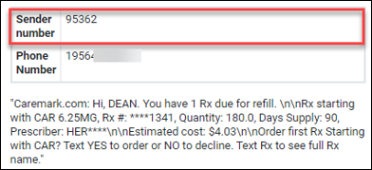

 Members not currently enrolled can enroll for **Text** alerts when calling **Customer Care** or on **Caremark.com** from the **Communications Preferences** page under **Alert settings**.

Top of the Document

|  |
| --- |
| Inactive 2-Way Text Alerts |

CVS Caremark suspended the delivery of the Zero Refills and Rx Expiring alerts sent via 2-Way SMS Text message. These communications were determined to duplicate information already provided to mail order customers in other forms and touchpoints. In addition, the content of the communications and limitations on the amount of information that can be shared through these channels were found to be confusing and resulted in a poor member experience and high call back rates into Customer Care.

|  |  |  |
| --- | --- | --- |
| **Alert** | **Description** | **Alert Type** |
| Zero Refills Notice/Reminder/Warning | Series of messages at intervals based on calculated consumption of day-supply (80%/90%/100%); Triggered when it is time for a refill and the Rx has zero refills remaining.  Call to action:  contact physician. | Refill Reminder |
| Rx Expiring  Notice/Reminder/Warning | Series of messages at intervals based on calculated consumption of day-supply (80%/90%/100%); Triggered when it is time for a refill and the Rx has zero refills remaining.  Call to action:  contact physician. | Refill Reminder |

Top of the Document

|  |
| --- |
| 2-Way Doctor Hold Messaging |

2-Way **Doctor Hold** messaging introduced in November 2018 enabled a 2-way conversation with our members which provides them with more information and improves the SMS experience overall.

* Member must be enrolled in CMP SMS Text alerts.
* When the **Doctor Hold** message meets the criteria, it will have 2-way capabilities.
* Members can text **INFO** for more options regarding the order on Hold.
* The **INFO** message will present the member with those options.
* Option 4 will allow members to submit feedback via a web survey when texting **INFO.**

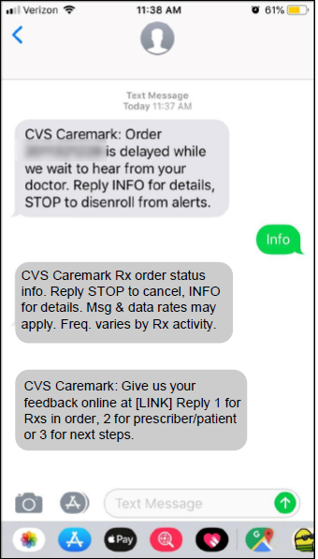

* Members have the ability to go back and forth through the options to get more details about their order.
* If an invalid response is received, the member will be able to re-engage the conversation.

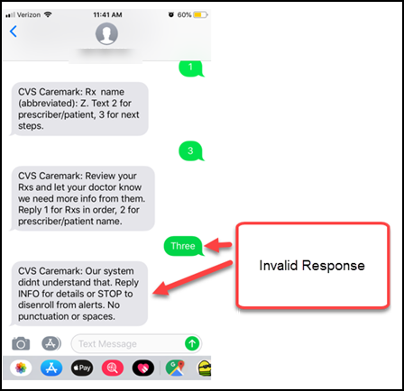

Top of the Document

|  |
| --- |
| 2-Way Text Messaging – Order Received Messaging |

* Member must be enrolled in CMP SMS Text alerts.
* Members who receive an “Order Received” SMS text alert will be able to reply to the SMS with pre-defined texts:
  + Rx’s in order.
  + Delivery date range.
  + Address for shipment.
* If any of the following applies, message will remain one way and member will not be able to reply:
  + If the order contains prescriptions for more than 1 family member.
  + If there are more than 6 prescriptions in the order.
  + Address is greater than 80 characters.
  + Order does not have a delivery date.

**Note:** If a member calls to cancel an order sent via 2-Way Text Messaging, refer to Cancel Order or Prescription Refill or New Prescription. If the order is not yet in process, create a Stop See comment in PeopleSafe. Refer to Stop See Comments.

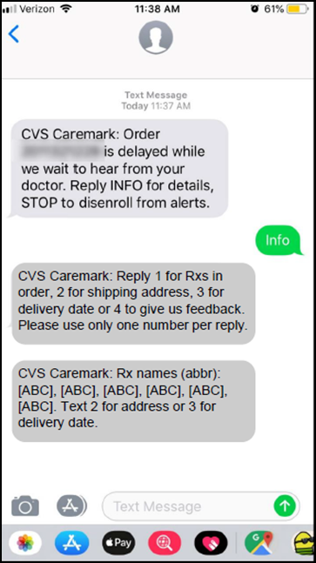

Top of the Document

|  |
| --- |
| 2-Way Text Messaging – Refill and Renewal |

**Members with greater than 6 prescriptions due for refill and renewal** **will receive a text message Refill and Renewal Reminder with a link to Easy Refill that will allow them to choose which prescriptions to act on**.

* When members click on the link, they are taken to their mobile web browser or the mobile app (if installed on their device).

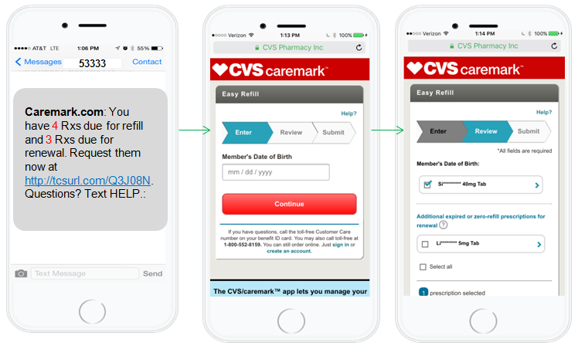

**Members who are enrolled in Text Refill Reminders can reply to the text to easily initiate the prescription refill/renewal process:**

* Refill/Renewal reminders will be combined at the Member/Phone Number level.
* This 2-Way texting experience will reduce the number of text message alerts and simplify the refill/renewal process.
* 2-Way text messages are open to all members who have a mail service benefit.
* Client branding and link customizations will be maintained.

**What Members need to do:**

* Members already enrolled in **Text** Refill Reminders will not need to do anything.
* Members not currently enrolled can enroll for **Text** Refill Reminders through Customer Care or on Caremark.com from the Communication Preferences page under Alert settings.

**What Members will receive:**

* Receive one combined Textmessage for refills and renewal reminders.
* Can reply **YES** to initiate the order.
* Receive Text confirmations for each reply (including invalid responses).
* Members with 1 to 6 prescriptions due for refill or renewal will receive a **2-Way text Refill and Renewal Reminder**.

 **If the member replies with anything other than YES, NO, or HELP, the response will be considered invalid.**

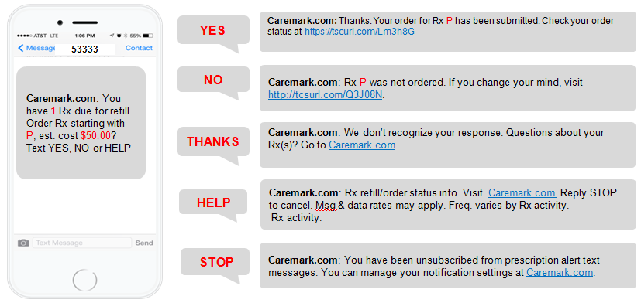

**Single Rx Member Experience**

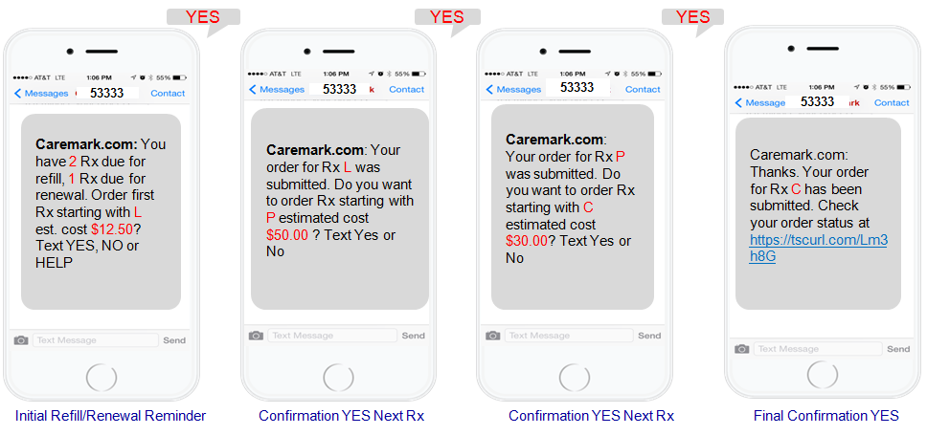

**Multiple RX Yes Member Response**

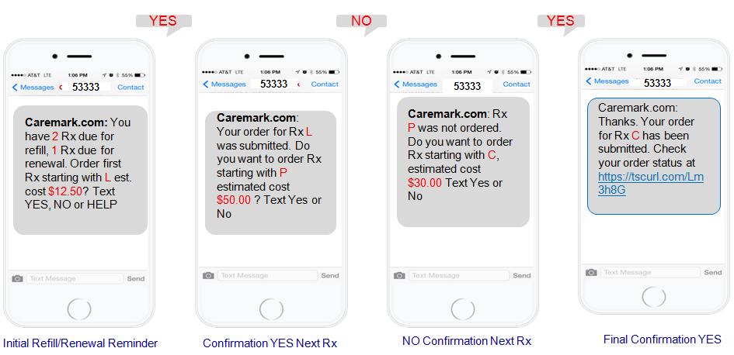

**Multiple RX YES/NO/YES Member Response**

Top of the Document

|  |
| --- |
| Related Documents |

**Parent Document:** [CALL 0045 Customer Care Web Support Email Response and Handling](https://policy.corp.cvscaremark.com/pnp/faces/DocRenderer?documentId=CALL-0045)

[CALL 0011 Authenticating Caller](https://policy.corp.cvscaremark.com/pnp/faces/DocRenderer?documentId=CALL-0011)

**Abbreviations/Definitions:** Customer Care Abbreviations, Definitions, and Terms

**Index:** Caremark.com - Work Instruction/Job Aid Index

Top of the Document

Not To Be Reproduced Or Disclosed to Others Without Prior Written Approval

**ELECTRONIC DATA = OFFICIAL VERSION – PAPER COPY – INFORMATIONAL ONLY**